Angular –Unit Test (Component)
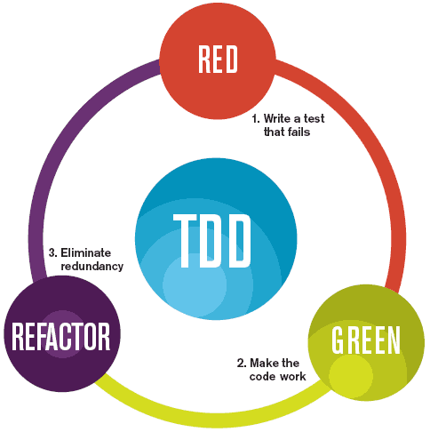
Testing your Angular application helps you check that it is working as you expect. Unit tests are crucial for catching bugs early, ensuring code quality, and facilitating safe refactoring.
Unit Test if one of the crucial aspects in Test-Driven Development (TDD) in modern Software Engineering practice.
The MVC architecture allows developers breaking down component, services, etc to much atomic entities. This will allow developers perform better unit test to projects.
In this lab, you will learn how to perform Unit Test on Angular Component. The lab also covers the use of Karma and Jasmine.
Perform the following tasks:
- Create a new Angular application app_ut_component, and open it with VS Code:
- Under VS Code, open the Terminal. Run command ng g c MyMath
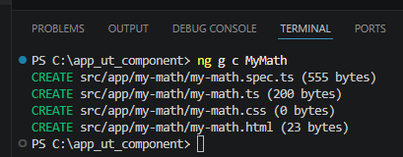
- In the my-math.ts, add new functions GCD and LCM
import { Component } from '@angular/core';

@Component({
selector: 'app-my-math',
imports: [],
templateUrl: './my-math.html',
styleUrl: './my-math.css',
})
export class MyMath {
public GCD(x:number, y:number):number{
while(y!=0){
let oldX:number = x;
x = y;
y = oldX % y;
}
return x;
}
public LCM(x:number, y:number):number{
return Math.floor((x * y)/this.GCD(x, y));
}
}

- In the app.ts, import MyMath component
import { Component, signal } from '@angular/core';
import { RouterOutlet } from '@angular/router';
import { MyMath } from './my-math/my-math';

@Component({
selector: 'app-root',
imports: [RouterOutlet, MyMath],
templateUrl: './app.html',
styleUrl: './app.css'
})
export class App {
protected readonly title = signal('app_ut_component');
}
- In the app.html, prepare this code
<app-my-math />
<router-outlet />
- In the my-math.html, prepare this code
table border="1">
<tr><th>Function Call</th><th>Expected</th><th>Actual</th></tr>
<tr><th>GCD(60, 96)</th><th>12</th><th>{{GCD(60, 96)}}</th></tr>
<tr><th>GCD(48, 120)</th><th>4</th><th>{{GCD(48, 120)}}</th></tr>
<tr><th>GCD(7, 11)</th><th>1</th><th>{{GCD(7, 11)}}</th></tr>
<tr><th>GCD(11, 7)</th><th>12</th><th>{{GCD(11, 7)}}</th></tr>
<tr><th>GCD(6, 8)</th><th>2</th><th>{{GCD(6, 8)}}</th></tr>
<tr><th>LCM(6, 8)</th><th>24</th><th>{{LCM(6, 8)}}</th></tr>
</table>
- Run the application, you should get this
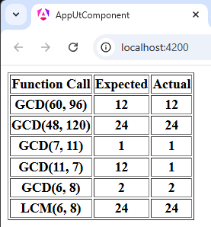
- Back to my-math.html, comment few test cases
<table border="1">
<tr><th>Function Call</th><th>Expected</th><th>Actual</th></tr>
<!--tr><th>GCD(60, 96)</th><th>12</th><th>{{GCD(60, 96)}}</th></tr-->
<tr><th>GCD(48, 120)</th><th>24</th><th>{{GCD(48, 120)}}</th></tr>
<!--tr><th>GCD(7, 11)</th><th>1</th><th>{{GCD(7, 11)}}</th></tr-->
<!--tr><th>GCD(11, 7)</th><th>12</th><th>{{GCD(11, 7)}}</th></tr-->
<tr><th>GCD(6, 8)</th><th>2</th><th>{{GCD(6, 8)}}</th></tr>
<tr><th>LCM(6, 8)</th><th>24</th><th>{{LCM(6, 8)}}</th></tr>
</table>
- Now the result will be like this
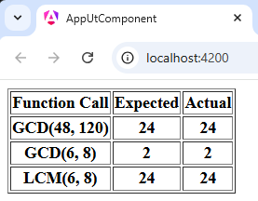
- Now, back to my-math.ts. Assuming that the developer cause mistake.
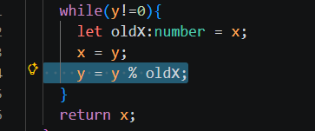
Save the file.
- Now, the result looks the same. Meaning even the developer make mistake, s/he might not know it basic on the displayed output. Therefore s/he will make assumption, the component is well done.
- Now, open the my-math.spec.ts. Prepare the code
import { ComponentFixture, TestBed } from '@angular/core/testing';

import { MyMath } from './my-math';

describe('MyMath', () => {
let component: MyMath;
let fixture: ComponentFixture<MyMath>;

beforeEach(async () => {
await TestBed.configureTestingModule({
imports: [MyMath],
}).compileComponents();

fixture = TestBed.createComponent(MyMath);
component = fixture.componentInstance;
await fixture.whenStable();
});

it('GCD(60, 96) should be 12', () => {
expect(component.GCD(60, 96)).eq(12);
});
it('GCD(48, 120) should be 24', () => {
expect(component.GCD(48, 120)).eq(24);
});
it('GCD(7, 11) should be 1', () => {
expect(component.GCD(7, 11)).eq(1);
});
it('GCD(11, 7) should be 1', () => {
expect(component.GCD(11, 7)).eq(1);
});
it('GCD(6, 8) should be 2', () => {
expect(component.GCD(6, 8)).eq(2);
});
it('LCM(6, 8) should be 24', () => {
expect(component.LCM(6, 8)).eq(24);
});
it('should create', () => {
expect(component).toBeTruthy();
});
});

- Save all files. Back to Terminal, press Ctrl+C to stop the application.
- Now, under the Terminal, run ng test
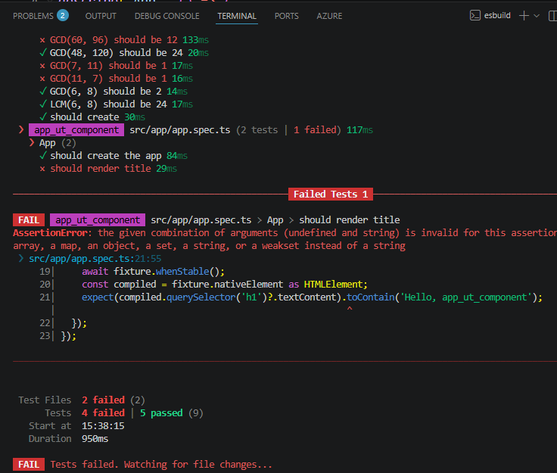
From the output, we found out that the component failed few cases.
- There also extra failed cases not caused by the MyMath component. To ignore it, go to app.spec.ts, comment the test case.
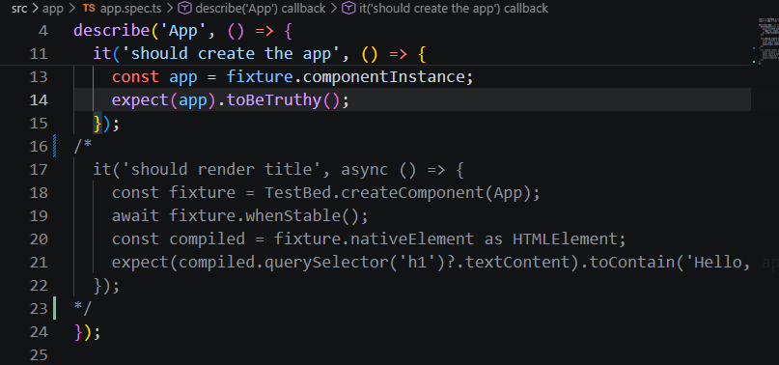
- Now we can just focus our own mistake
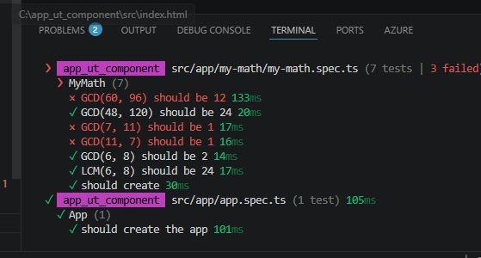
- Stop the Test by pressing Ctrl+C in Terminal.

Setting Karma and Jasmine
- To add Karma and Jasmine to project, run the following command in Terminal window
npm install --save-dev karma karma-chrome-launcher karma-coverage karma-jasmine karma-jasmine-html-reporter jasmine-core @types/jasmine
- Open file tsconfig.spec.json, change the setting
{
"extends": "./tsconfig.json",
"compilerOptions": {
"outDir": "./out-tsc/spec",
"types": ["jasmine"]
},
"include": [
"src/**/*.d.ts",
"src/**/*.spec.ts"
]
}
- Open file angular.json, change the setting 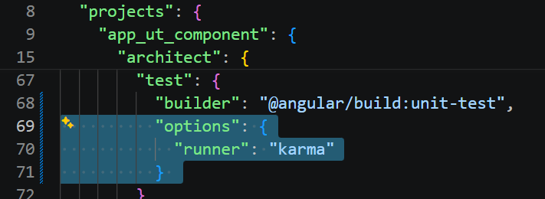
- Open file my-math.spec.ts, change all the .eq to .toEqual. This because under Jasmine, the method is different.
it('GCD(60, 96) should be 12', () => {
expect(component.GCD(60, 96)).toEqual(12);
});
it('GCD(48, 120) should be 24', () => {
expect(component.GCD(48, 120)).toEqual(24);
});
it('GCD(7, 11) should be 1', () => {
expect(component.GCD(7, 11)).toEqual(1);
});
it('GCD(11, 7) should be 1', () => {
expect(component.GCD(11, 7)).toEqual(1);
});
it('GCD(6, 8) should be 2', () => {
expect(component.GCD(6, 8)).toEqual(2);
});
it('LCM(6, 8) should be 24', () => {
expect(component.LCM(6, 8)).toEqual(24);
});
- Save all files.
- Rerun the test again using ng test command.
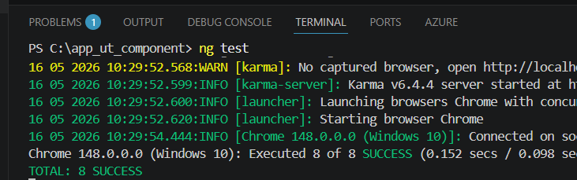
Meanwhile, you will see the Jasmine launch the test result in browser.
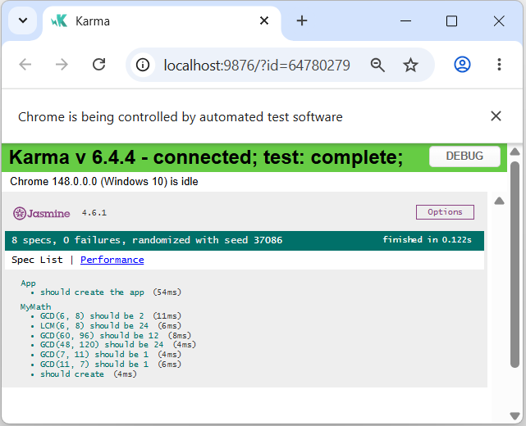
- While the test is running. Back to my-math.ts, repeat the mistake.
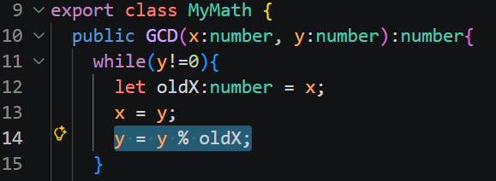
- Save the file. Back to test browser.
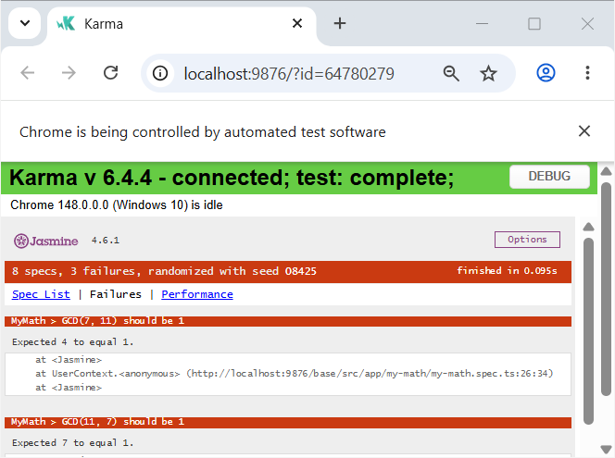
- Select the Spec List
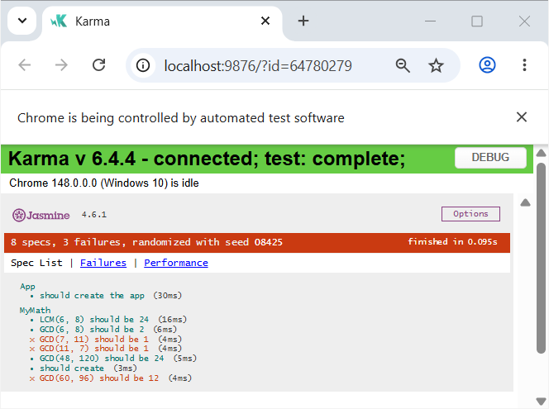
- Back to Terminal window. Stop the test.
- If you want the project equip with Karma and Jasmine without manually setup as shown before, you can use following command during project creation:
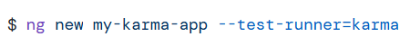
Reference: https://angular.dev/guide/testing/karma

